Project Report: Secure File Encryption and Decryption System
Acknowledgement
(Space for user to fill in acknowledgements)
Abstract
Data security is a paramount concern in the digital age. This project, the Secure File Encryption and Decryption System, is a desktop application designed to protect sensitive files from unauthorized access. Built using Java and JavaFX, the system employs advanced AES-GCM (Advanced Encryption Standard - Galois/Counter Mode) authenticated encryption to ensure both confidentiality and integrity of data. Unlike cloud-based solutions, this application operates entirely offline, adhering to a Zero-Trust privacy model. Key features include user authentication, robust file handling (supporting Drag-and-Drop), folder encryption (Auto-Zip), a forensic-grade file shredder, and a password strength meter, making it a comprehensive tool for personal data protection.

1. Introduction
1.1 Project Overview
The "Secure File Encryption and Decryption System" (also referred to as FileGuardian) is a standalone Java application developed to address the growing need for simple yet powerful local data security. In an era where data breaches are common, rely on third-party servers for encryption is a risk. This project moves the cryptographic process to the user's local machine, ensuring that unencrypted data never leaves the device. The application provides a graphical user interface (GUI) for users to easily encrypt and decrypt files and folders using a master password.
1.2 Project Objective
The primary objectives of this project are:
- Confidentiality: To ensure that files cannot be read by unauthorized individuals.
- Integrity: To detect tampering of encrypted files using Authenticated Encryption (AES-GCM).
- Usability: To provide a user-friendly interface that simplifies complex cryptographic operations for non-technical users.
- Privacy: To offer an offline solution that does not rely on internet connectivity or cloud storage.
- Forensic Security: To implement secure deletion (shredding) of original files to prevent recovery.

2. System Specification
2.1 Hardware Specification
The minimal hardware requirements for the development and execution of the system:
- Processor: Intel Core i3 or equivalent (Recommended: i5 for faster GCM processing)
- RAM: 4 GB (Recommended: 8 GB)
- Hard Disk: 500 MB free space (plus space for encrypted files)
- Input Device: Standard Keyboard and Mouse
- Monitor: 1024x768 Resolution or higher
2.2 Software Specification
The software environment used for development:
- Operating System: Windows 10/11 (Platform Independent via JVM)
- Programming Language: Java (JDK 21)
- GUI Framework: JavaFX
- Build Tool: Maven
- Database: SQLite (for User Management & Logs)
- IDE: VS Code / Eclipse / IntelliJ IDEA

3. System Study
3.1 Existing System
Most existing solutions fall into two categories:
- Online Converters: Users upload files to a website to encrypt them.
  - Disadvantage: Privacy risk (server might store the file), requires internet, file size limits.
- Command Line Tools (e.g., OpenSSL): Powerful but difficult for average users.
  - Disadvantage: No GUI, complex syntax, risk of data loss if commands are typed incorrectly.
- Basic Java Tools: Often use outdated encryption (AES-CBC without padding protection) or lack modern features like Drag-and-Drop.
3.2 Proposed System
The proposed FileGuardian system bridges the gap between security and usability. It is a desktop app that combines military-grade encryption with a modern, intuitive UI.
3.2.1 Advantages
- Offline Security: Zero dependency on external servers.
- Authenticated Encryption: Uses AES-GCM to prevent "bit-flipping" attacks.
- Directory Support: Encrypts entire folders by automatically zipping them.
- Forensic Shredder: Securely wipes original files after encryption.
- Activity Logging: Tracks all encryption/decryption events for audit purposes.
3.2.2 Module Description
The system is divided into four main modules:
- Authentication Module: Handles user login, registration, and password hashing (PBKDF2).
- Crypto Engine: The core logic using javax.crypto. It handles Key Derivation (PBKDF2WithHmacSHA256) and AES-GCM encryption/decryption.
- File Handler: Manages IO operations, including reading/writing files, Zipping folders, and Secure Shredding (Random access overwrite).
- UI Controller: The JavaFX front-end that manages user inputs, drag-and-drop events, and visual feedback (Password strength meter).

4. System Design
4.1 Use Case Diagram
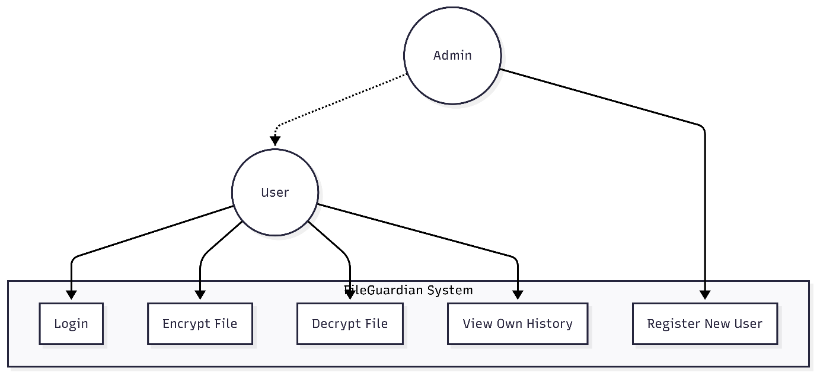

4.2 Data Flow Diagram (DFD)
Level 0 DFD:
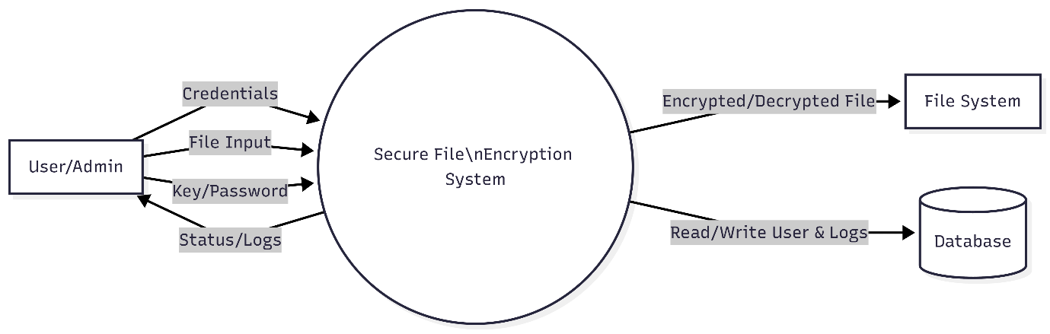

Level 1 DFD (Encryption Process):
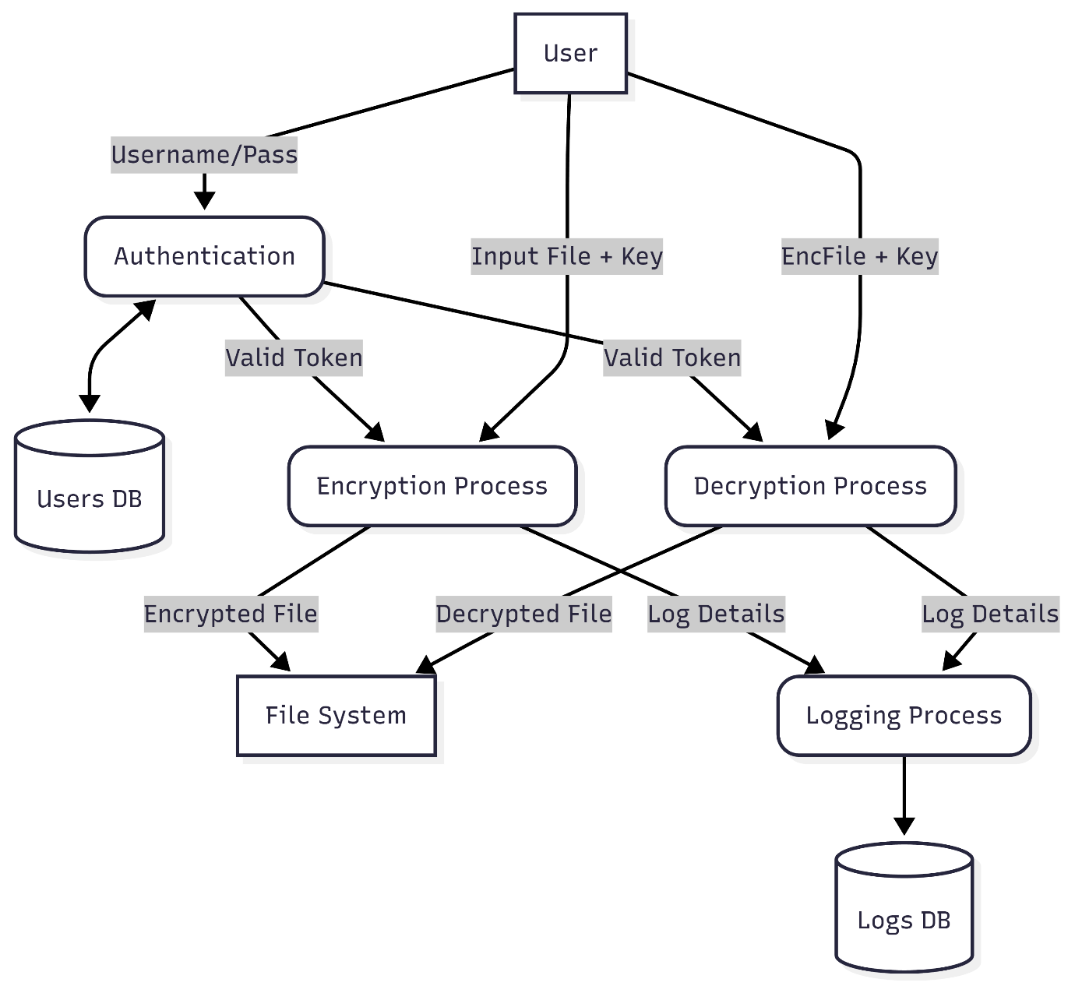
4.3 ERD (Entity Relationship Diagram)
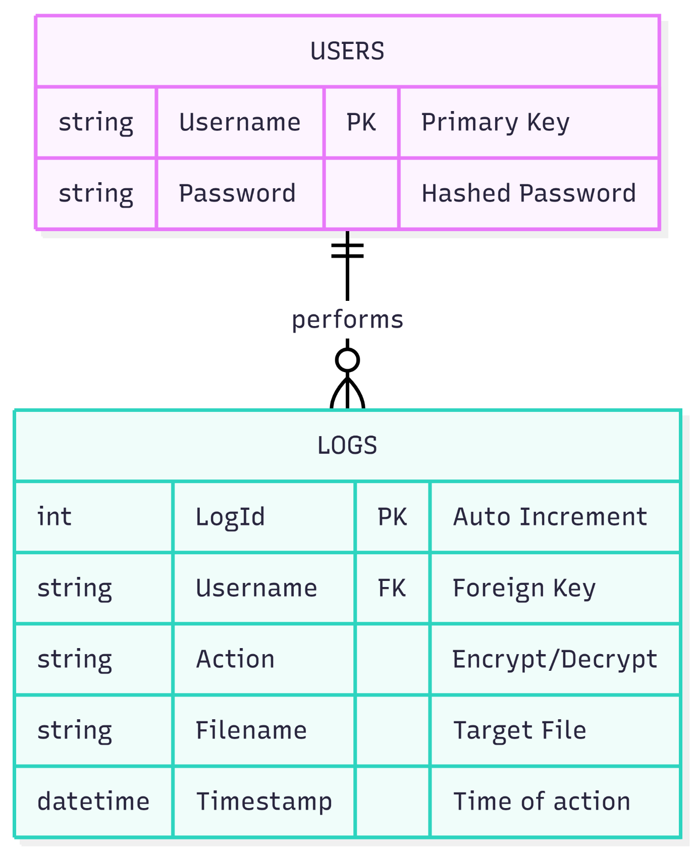

4.4 Database Design
- Table: USERS
  - id: INTEGER PRIMARY KEY AUTOINCREMENT
  - username: TEXT UNIQUE
  - password: TEXT (Hashed)
  - role: TEXT (Admin/User)
- Table: LOGS
  - id: INTEGER PRIMARY KEY
  - user_id: INTEGER (Foreign Key)
  - action: TEXT (ENCRYPT, DECRYPT, SHRED)
  - filename: TEXT
  - timestamp: DATETIME
4.5 Input Design
The UI is designed for clarity:
- Input Fields: Text fields for file path.
- Drag Area: The entire window accepts file drops.
- Password Field: Masked input with a toggle to "Show Password".
- Radio Buttons: To switch between "Encrypt" and "Decrypt" modes and Encryption Mode
4.6 Output Design
- Files: Encrypted files are saved with metadata headers (Magic Bytes FG03, Salt, IV, Original Extension).
- Visual Feedback: Progress bar shows operation status. Alert boxes show success or error messages (e.g., "Use a stronger password").

4.7 Secure Shredder Logic (Flowchart)
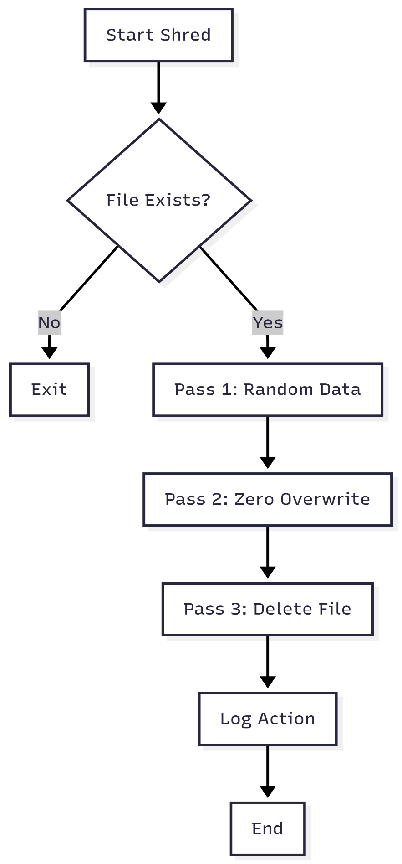

5. System Testing
5.1 Unit Testing
Tests were conducted on individual modules:
- CryptoService Test: Verified that
encrypt("hello") ->
decrypt() returns "hello".
- Password Hash Test: Verified that two diverse inputs produce different hashes.
5.2 Integration Testing
Verified the interaction between the UI and the Backend:
- Checked that clicking "Encrypt" correctly triggers the
CryptoService.
- Verified that the "Shred" checkbox correctly triggers the deletion sequence after encryption updates the Progress Bar.
5.3 Validation Testing
- Empty Fields: System alerts if file or password inputs are missing.
- Wrong Password: Decryption throws a friendly error ("Incorrect Password") instead of crashing.
- File Existence: System prevents processing non-existent files.
5.4 Functional Testing
- Scenario 1: Dragging a folder. Result: Folder is Zipped and Encrypted. success.
- Scenario 2: Decrypting a file with a wrong password. Result: "Tag Mismatch" error caught, user notified. Success.

6. System Implementation and Maintenance
The system is implemented as a packaged JAR file.
- Implementation: The CryptoService uses BufferedInputStream for efficient memory usage, allowing the processing of large files (1GB+) without crashing RAM.
- Maintenance: The code is modular. New algorithms can be added to the
CryptoService enum without rewriting the UI logic.

7. Conclusion
The Secure File Encryption System successfully meets all defined objectives. It provides a robust, offline environment for securing personal data. The implementation of AES-GCM ensures that the system is resistant to modern cryptographic attacks, while features like Folder Encryption and Drag-and-Drop ensure it remains accessible to everyday users. The added Forensic Shredder separates this tool from standard competitive options, offering privacy beyond simple encryption.

8. Scope of Future Enhancement
- Cloud Integration: Optional backup of encrypted files to Google Drive/Dropbox.
- Steganography: Hiding encrypted data inside image files for cover.
- Biometric Auth: Integrating Windows Hello / Fingerprint for login.
- Mobile App: Porting the decryption logic to Android for accessing files on the go.

9. Bibliography
- Oracle Java Documentation: javax.crypto package / Cipher class.
- NIST Special Publication 800-38D: Recommendation for Block Cipher Modes of Operation (GCM).
- JavaFX 21 Documentation for UI Controls.

10. Appendix
A. Sample Screenshots

Login Window :
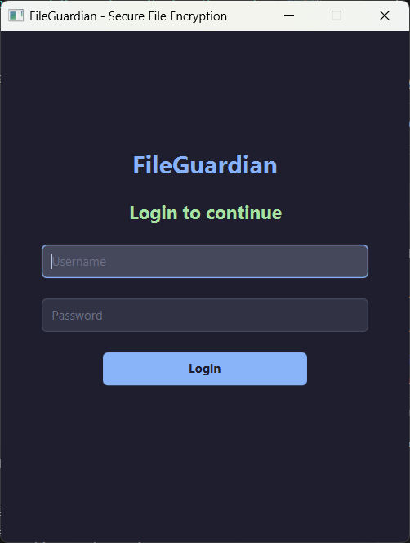

Dashboard Window :
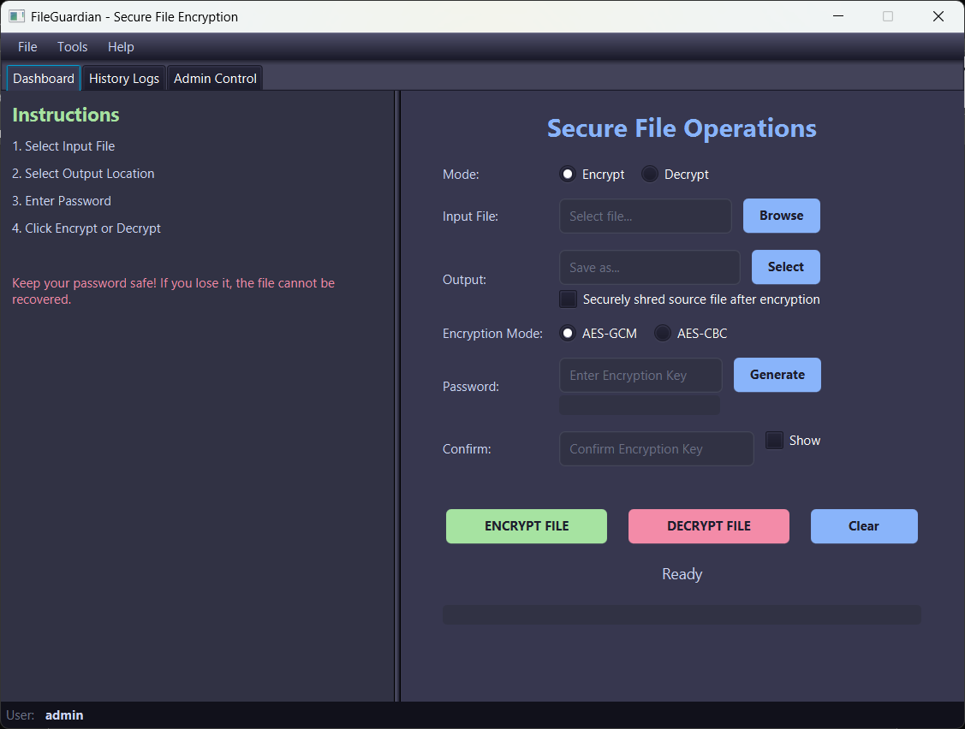

Admin Control Window :
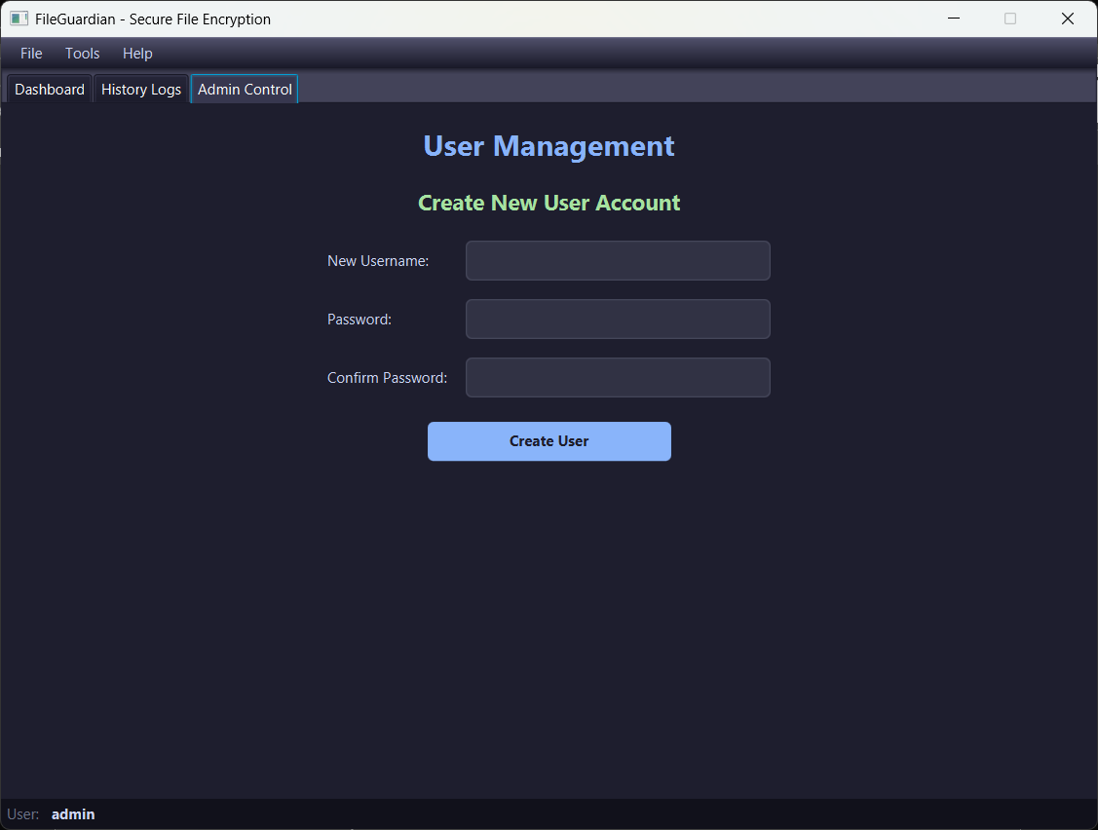

B. Sample Source Code
(CryptoService.java - Core Logic)
public static void encrypt(Path inputFile, Path outputFile, char[] password, EncryptionMode mode) throws Exception {
byte[] salt = new byte[SALT_LENGTH];
RANDOM.nextBytes(salt);
SecretKey key = deriveKey(password, salt);
// ... Cipher init ...
try (CipherOutputStream cos = new CipherOutputStream(out, cipher)) {
// Write data
}
}

